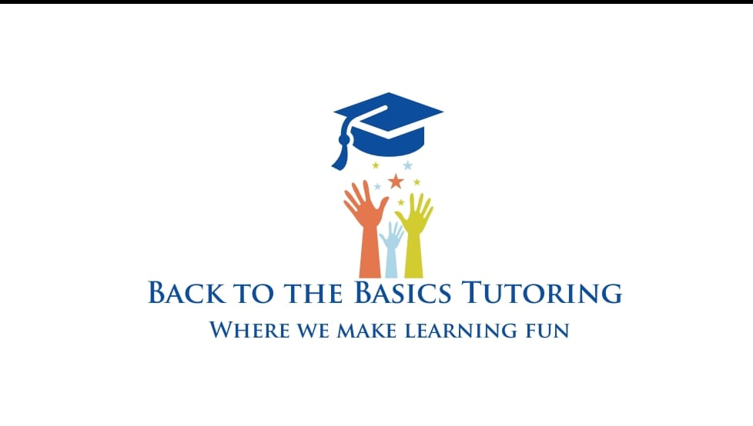
BACK TO THE BASICS TUTORING LLC PHOTO/VIDEO RELEASE FORM

I, _____________________________________________________________(please print), grant permission to Back to the Basics Tutoring LLC and its agents, volunteers and employees the irrevocable and unrestricted right to create or reproduce the photographs, audio and/or video images taken of my child, or members of my family, with or without their name or any other identifying information, for the purpose of publication, promotion, illustration, advertising, in any manner or in any medium. I hereby release Back to the Basics Tutoring LLC and its legal representatives for all claims and liability relating to said images or video. Furthermore, I grant permission to use my statements that were given during an interview or guest lecture, with or without my name, for the purpose of advertising and publicity without restriction. I waive my right to any compensation regarding said images, videos, interviews, statements and lectures.

Parent/Guardian Printed Name: _________________________________________________________
Parent/Guardian Signature: _____________________________________________________________
Date:________________________________________________________________________________

